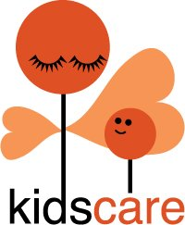

Strategic plan 2023-2025
Continued Resilience for Sustainability!
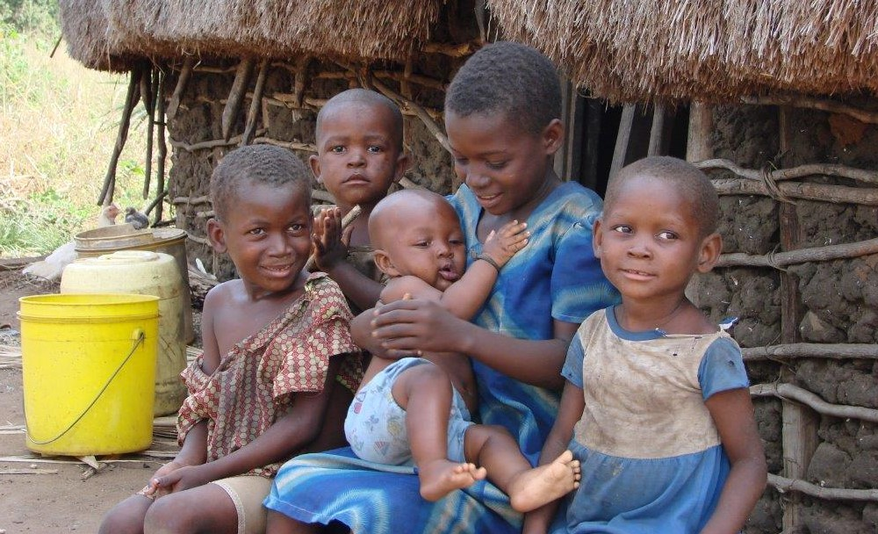
‘Every Child needs a Family’
Sustainable Homecare for orphans and vulnerable children in Lunga Lunga Sub-county, Kwale, Kenya.
November 2022

Contents
1. Summary 3
2. About KidsCare 4
3. Continued resilience for sustainability 5
4. Mission and Vision 2023 -2025 6
5. Four pillars make our strategy 7
5.1 Pillar1: Connected with the beneficiaries/ communities. 7
5.2 National and International (funding) partners 11
5.3 Strengthen own quality and competences 12
5.4 Being visible for all stakeholders 13
6. KidsCare Programs 2023-2025 14
7. Monitoring & Evaluation 17
8. Finance 18
Appendix: 19
A. Organisation Chart 19
B. Our programs 2023 -2025 19
C. Year plan 2023 19

1. Summary
This strategic plan clarifies how we want to realize our mission, vision and strategy for 2023- 2025. It includes information of our donors and other stakeholders. Furthermore, it gives directions to our well respected KidsCare Team. KidsCare has grown into a well-functioning and dedicated organization, committed to helping orphans and vulnerable children based on the belief that ‘every child needs a family’. After 12 years of experience it is time for a next step. KidsCare is ready to work on sustainable homecare for more than 2500 orphans and vulnerable children.
Sustainability can only be reached by an independent and result driven KidsCare organization. Together with her partners, KidsCare will go straightforward to reach the impact that brings her credibility, legitimacy, accountability and authority. This strong position enables KidsCare to improve the quality of service provision and homecare activities for orphans and vulnerable children.
To be able to structurally work towards our goals, we shall use 4 pillars which are divided into: Connected with the beneficiaries/ communities, National and International (funding) partners, Strengthen own quality and competences, and Being visible for all stakeholders.
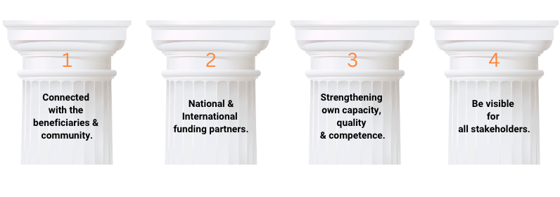
In line with the pillars we offer the following programs in 2023 -2025:
- Community Based Homecare Child Protection and Beekeeping (CBHCPB) program (First phase started June 2020 for 3 years)
- Community Based Homecare and Beekeeping (CBHB) program (Start in July 2023)
- Community Child Protection Committees (CCPC) program (Actual restart in January 2023 for in total 3 years)
- Special School Units- 2 (SSU-2) program (2 years’ program start January 2023. Is successor of SSU-1)
- Special Services for Children with Physical Abilities (SS-P) program. (start in revised form in January 2023)
- Community Based Homecare for Children with Mental Abilities (CBH-M) program (start in revised form in September 2023)
- Intervention projects 2023 (to develop and start together with partners and depending of the needs/available budgets.

We thank our partners, the Dutch KidsCare board and Wilde Ganzen for the great collaboration so far and ask her to join us on this new journey. We greatly appreciate feedback on this strategic plan.
Ali S. Mwaziro

2. About KidsCare
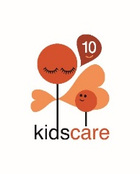
KidsCare believes that every child deserves the right to build on their future and develop the talents they have been born with. KidsCare Kenya is a registered Trust. Established in 2010 and working in Lunga lunga Sub-County, Kwale, Kenya. The sub county can be characterized as a low- developed rural area. The KidsCare organization currently consists of a team of 40 employees (most of them are social workers), who work tirelessly to help children who are in dire need of help.
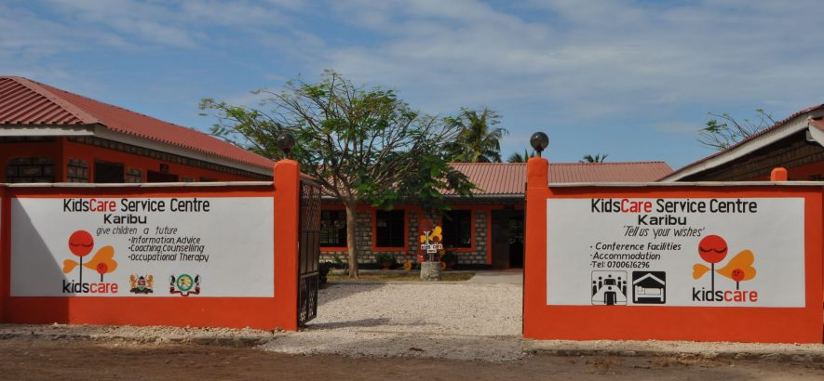
From the start, KidsCare has focused on helping orphans and vulnerable children who are living with their family members in their own home environment. With a team of social workers, KidsCare started community-based home care programs for these families especially for the ones living in very poor conditions. With social and economic assistance, KidsCare is now helping about 2500 children.

Besides that, KidsCare also has implemented programs to help Children with special abilities in their homes. About 100 Children with physical disabilities receive weekly specialised services from three occupational therapists. Around 125 children with special mental abilities are benefiting from the six established Special School Units in the sub-county. These children and their families are also monitored and guided by KidsCare social workers.
KidsCare has successfully delivered its programs in these communities by making them community owned. The sustainability is maintained by having close cooperation with 120 KidsCare Community Volunteers (KCVs), 240 Community Child Protection Committees (CCPCs) and 60 KidsCare Ward Team Members (Comprising of area chiefs, Ward /village administrators, hospital, school and other representatives from government and other organizations) who monitor the KidsCare programs.
KidsCare is a transparent organisation. She reports on quarterly basis to all its partners and stakeholders and also seeks advices on how and what other activities can be done according to the community needs. The open way of working also applies to intensive cooperation and sustainable relationships with her donors and program funders. See for more details www.kidscare.or.ke (Kenya, English language) and www.kidscarekenia.nl (The Netherlands, Dutch language).

3. Continued resilience for sustainability
In 2018 KidsCare Kenya published a report on sustainability which we referred to a sustainability model with seven dimensions. We conclude that success in all of the seven dimensions model should form a good basis for a sustainable organization.
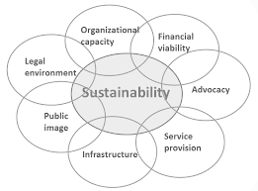

Reflecting on our current general strategy, we see major overlap with the sustainability dimensions. Over the past years the seven dimensions have been slightly adjusted to fit KidsCare best interest and ensure that we enhance all the dimensions. With a team of 40 local employees, we have successfully cooperated with the government and other stakeholders to implement our programs.
Being an independent and sustainable organisation, we must recognise that this sustainability model is not enough because any income from the vulnerable children and their families is no option. A ‘sustainable model’ for a social organisations as KidsCare needs always the (financial) support from relevant government organisations and as long as that’s not there it depends automatically from other national and International funders. Realising that we have to conclude that sustainability only can be reached by being aware that continued resilience is needed for being sustainable. That conclusion give direction to the vision in the next chapter.

4. Mission and Vision 2023 -2025
KidsCare Kenya believes that every child deserves the right to build on their future and develop the talents they have been born with. From the start in 2010, KidsCare has focused on helping orphans who had been taken in by a family member in their home environment (2500 children on yearly basis).

KidsCare is aware that her homecare approach is still unique in Kenya. KidsCare was and still is a frontrunner (Koploper). In the last 12 years we have seen that more and more stakeholders are convinced of our statement that ‘every child needs a family’ yet there are still many orphanages in Kenya and Children with Special Abilities are sent to special boarding schools. This way they grow up without a family. KidsCare is ready to spread her messages about the advantages of Homecare. Initiatives to start platforms together with stakeholders can be expected.
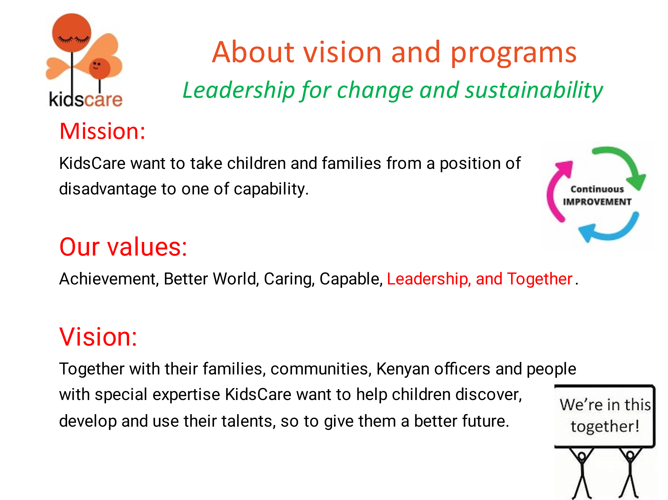
The board of KidsCare Kenya has a strong aim of achieving a position of 'sustainability and independence' in the long term. KidsCare wants a strong position from which she works together in equal partnership with her Dutch sister organization, government and other stakeholders. This contributes with the necessary capacity, expertise and financial resources to the aid of children in the Lunga Lunga sub-county.

5. Four pillars make our strategy
It is desirable that one day the government in Kenya will sufficiently provide for the well-being of the poorest families in the Lunga Lunga sub-county. But from a realistic point of view, the board cannot name a year for this. Developments in the climate, economy, politics and other things are currently affecting the living situations of the poorest families.

For the time being, it is realistic to say that KidsCare and its care for needy children will therefore remain dependent on its donors for an indefinite period. This will not hinder us in our ambition to stay in the position of 'sustainability and independence'. Therefore we have formed 4 pillars for continued resilience:


4 pillars to become resilient:
- Connected with the beneficiaries/ communities.
- National and International (funding) partners.
- Strengthen own quality and competences.
- Being visible for all stakeholders.

Sustainability must be reached by an independent and result driven KidsCare board and team. Together with (equal) partners, KidsCare board and team will be straight forward to achieve the impact that brings her credibility, legitimacy, accountability, and authority.
KidsCare has already created such a broad participation with her beneficiaries in the communities, with the government and other relevant organisations. This is a working process that must continue or even increase to bring KidsCare a strong position in the region and work convincingly for national and/or international funding partners.
Besides that it is important to increase the qualities/ competences of the board and team members. They have to perform well in their duties, and also be able to independently propagate the created position to her national and international funding partners. Therefore they have to be able to develop and maintain the networks and to make their own program/ project proposals, applications and reports.
The board expects that ‘up-scaling’ can help to reach the sustainability goals, but in the current unstable situation the board prefer to concentrate in the coming period on strengthening the quality and not the quantity of our homecare services.

5.1 Connected with the beneficiaries/ communities.
Together we can do more! We form alliances; build strong relationships with involved parties from all network levels. We encourage cooperation and shared lessons learned with others and work with many to make a difference. We aim to do this in a structured way, reaching for the right partners.

To create a clear overview we work with a pyramid which is divided into three layers starting from below to above:
- Communities; volunteers and beneficiaries
- Professionals, specialist
- Decision makers

Furthermore we will explain the above in three subjects:
- Main goal
- Current situation
- Desired results 2023 - 2025

The pyramid
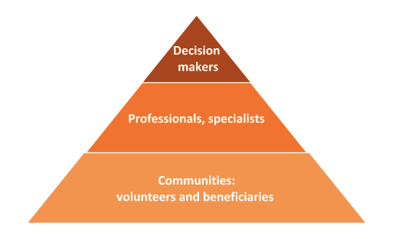

For each group KidsCare will make a stakeholder analysis of the most relevant organizations and officials. The analysis will be made on organization and on department/program level. Doing that we are aware of and prioritize the right organizations to partner/cooperate with.

Communities: Beneficiaries

Main goal
Being the solution to their own problems by stating what they are facing. To be their credible representative and work together with the community volunteers. We want the community to own their own projects.

Current situation
- Approach: we create awareness in the selected areas, we involve the community and get to know their needs, problems and solutions, and together we implement the plan.
- Status of beneficiaries: at the moment we have 240 Community Based Homecare Child Protection and Bee Keeping (CBHCPB) beneficiaries, 100 Special Services for children with physical abilities (SS-P), and 125 Special School Units (SSU) learners.
- Services:
- CBHCPB: visiting the households twice a month, monitoring the progress and setting short and long term goals. Give trainings once a month for empowerment and also health issues.
- SS-P: Occupational therapies provided once a week to improve physical health plus support groups for “income generating” activities.
- SSU: Educational inclusion for children with special mental abilities at 6 special school units.

Desired results 2023 - 2025
- Approach: Continue creating awareness in different villages, involving the community and get to know their needs, problems and solutions, and together we implement the plan. We want to reach out to a larger population in the Lunga Lunga Sub-county.
- Status of beneficiaries: For the CBHCPB, we want to increase the number of households with 160 new ones starting from July 2023 whereas we will still keep monitoring the current 240 households. When it comes to SS-P and SSUs, we want to ensure the implementation of the new CSA (Children with Special Abilities) policies while maintaining the numbers respectively 100 and 125.
- Services:
- CBHCPB: Proceed with the current visits and capacity building to the new 160 households and implement follow-up visits once a month for the existing 240 households.
- SS-P: Continue with occupational therapies once a week to improve physical health plus support groups for “income generating” activities.
- SSU: Implementation of the quality improvement plan for the SSU-2 program and continue with the educational inclusion for children with special mental abilities in the 6 special school units.

Communities: volunteers

Main goal
Be a strong voice to create awareness, lobby and to do advocacy. To be their credible representative and work together with the community beneficiaries. We want the volunteers to be highly involved with the beneficiaries.

Current situation
- Approach: We use the local authority to acquire the volunteers who can assist in monitoring and implementation within their communities.
- Status of volunteers: At the moment we have 120 KidsCare volunteers who work on the implementation and support of KidsCare programs, 240 Community Child Protection Committees and 60 KidsCare Ward teams.
- Services: Advocacy, support and awareness creation. The volunteers can also report to the social worker assigned to the village whenever needs occur.

Desired results 2023 - 2025
- Approach: Increase knowledge and skills of the volunteers by giving them specific trainings like: mentoring, leadership and coaching.
- Status of volunteers: In the coming two years we want to continue working with the existing volunteers to empower them achieve a level of independence.
- Services: Improving the quality of services and support to the community by the volunteers.

Professionals and specialists

Main goal
Attracting specialized knowledge and activating others to increase the capacity, quality and quantity of KidsCare Homecare programs and organizations.

Current situation
  - Approach: Our professionals are carefully selected by networking and lobbying.
  - Status of professionals: When it comes to the CBHB program, we work with experts in the bee keeping and health industry. We also work with international organizations for support. When it comes to the SS-P and SSUs, we are working with government and other relevant stakeholders on different levels for screening, assessments, provision of assistive devices and placement of specialized services.
  - Services: Capacity buildings and networking, Children with Special Abilities screenings, assessments, placement of specialized services, provision of assistive devices and advisory.

Desired results 2023 - 2025
  - Approach: Enhance network and spread our wings with the government and other relevant stakeholders. We also want to increase the number of professionals we work with.
  - Status of Professionals including services: Implementation of the quality program services by the professionals. Strengthening KidsCare relationship with the professionals for continued support.

Decision makers

Main goal
Sharing the vision and mission to help vulnerable children, cooperate by dividing the responsibilities and tasks, and complementing and strengthening each other.
Current situation
- Approach: Activating stakeholders to play their roles in different projects.
- Services: Development and implementation of KidsCare programs in partnership with the government and other relevant stakeholders.

Desired results 2023 - 2025
- Approach: Analyzing the desired stakeholders on the level of decision makers depending on the program. Prioritize and target relevant stakeholders whereas maintain the connections by sharing KidsCare’s vision and mission with the relevant local authorities.
- Services: Analyzing, developing and implementing the programs effectively.

5.2 National and International (funding) partners
Financial viability of the organisation and its programs is a need. A smart funding plan including financial projections should be in place and approved by the board. Such plan will include diverse income sources and avoid reliance on a single stream. The plan needs to be balanced using a variety of fundraising techniques appropriate to programmes and the mission. Funding should be sought from individuals, trusts, foundations, corporate social investment and government departments. Within this, we focus on both national and international market. Our team should be capable of executing this fundraising plan, which requires the improvement of skills and techniques.

Main goal
- Being able to cover short, medium and long-term financial commitments to cover the yearly KidsCare exploitation and to have stable liquidity and solvency.
- To find revenue sources in line with our strategy and increase our ability to have the impact we desire with partners.

Situation KidsCare
KidsCare Kenya is still for more than 70% financially depending on her Dutch partners (Stichting KidsCare and Wilde Ganzen). The aim is to make KidsCare Kenya less dependent on her current partners. We want to change that during the period 2023 -2025 to about 30%.

Strategy
- Clarify the required financial resources of the coming years to meet the exploitation and to have enough liquidity and solvency.
- Develop an effective fundraising plan. This plan must be based on:
- The impact attracts the resources.
- Our homecare program strategy for children.
- The needs in the environment.
- Our (intensive) cooperation with the government and other partners
- Our strategy to create more and more tangible impact (to open doors).
- An international view on the possibilities to do project applications.
- Gradually reducing our KidsCare Kenya’s financial dependency.
- Make a start within the current possibilities to gain experience and do research before taking more steps.
- Only invest in relationships with funders that have interest in homecare for children.
- Use innovative fundraising techniques.
Desired results (general)
- To have good relationships with Kenyan or international partners who are able to bring in the right capacity and/or financial resources for the homecare programs.
- To have enough financial resources to cover the exploitation on the right quality level.
- To have an effective plan to cover the long term financial viability.
- To have enough competency and capacity in the team towards maintaining and reaching the needed financial viability.

5.3 Strengthen own quality and competences
Organizational capacity is about the potential of our organization to strengthen the internal expertise to be productive. Programs and projects being undertaken by the board, employees and volunteers should be of professional and with adequate resources in place.

Main goal
To have an internal organization consisting of well-functioning leaders, sharing the KidsCare mission and covering the need to lead and make change via homecare programs.

- Current situation

- Board
The board is currently comprised of 6 active members who are focused to bring, connect and give leadership to the organization based on their area of specialization as per their portfolio. The main aim of the board is to lead and advise the organization towards reaching her desired short and long term goals.

- Management team
The management team consists of 2 groups:
- The Programs Team: They are in charge of bringing leadership in the homecare programs, planning on management level, realizing the fundraising plan and networking.
- The General Management Team: they are in charge of providing leadership and strengthening the team at departmental levels.

- Team
The KidsCare team is comprised of social workers, occupational therapists, administration team, and facility staffs. The social workers and occupational therapists are in charge of daily homecare operations at the community level. The administration team is in charge of bringing office operations in order while the facility team is in charge of delivering services to clients and maintaining the buildings.

Find the chart of KidsCare organization in Appendix A

2. Desired results (Board, Management Team, and Team level)

- Board
- To connect the board more with the environment by forming an advisory board of committee consisting of community representative.
- To strengthen the board by activating members and bringing new members on board with clear portfolios.

- Management Team
- To have an effective networking and fundraising plan by activating the management team to take charge in their different areas towards reaching fundraising desired goals.
- To strengthen the management team through capacity building, appraisals, team building and development of clear HR policy.
- To deliver quality services by developing standard tools for reporting, proposals, monitoring and evaluation.
- To have an effective communication system by improving the IT operations.
- To improve record keeping system by developing a clear recording structure and documentation.
- To improve financial accountability by liaising and monitoring budgets in relation with programs activities.

- Team
- To establish an effective and productive team by having the right people at the right position.
- To improve the knowledge and skills of the employees by continues trainings and workshops.
- To have a proactive team with leadership skills by giving people space for own input.
- To provide quality services by adhering standard operating procedures (SOPs).

5.4 Being visible for all stakeholders
Being visible for all stakeholders, partners, donors and like- minded parties including building KidsCare brand and image to the outside world towards gaining trust and support in working together.

Current Situation
- KidsCare have an active website and social media pages where we frequently share news about the impact of our programs.
- Newsletters and fliers are distributed to partners, visitors and stakeholders.
- Volunteers and board members act as KidsCare ambassadors where they have the authority to spread KidsCare news to the outside world.
- Sharing of quarterly and annual reports to potential donors and stakeholders.

Desired results
- Develop and implement a professional communication and promotion plan with the following contents:
- Develop a brand statement
- Identify our unique selling proposition
- Identify our business objectives
- Develop audience / customer personas
- Understand other key publics
- Determine what the world needs to know about us
- Choose the rights channels
- Plan a messaging matrix
- Determine our important events and campaigns
- Set our communications goals
- Plan content and campaigns on our marketing calendar (including budgets)

6. KidsCare Programs 2023-2025
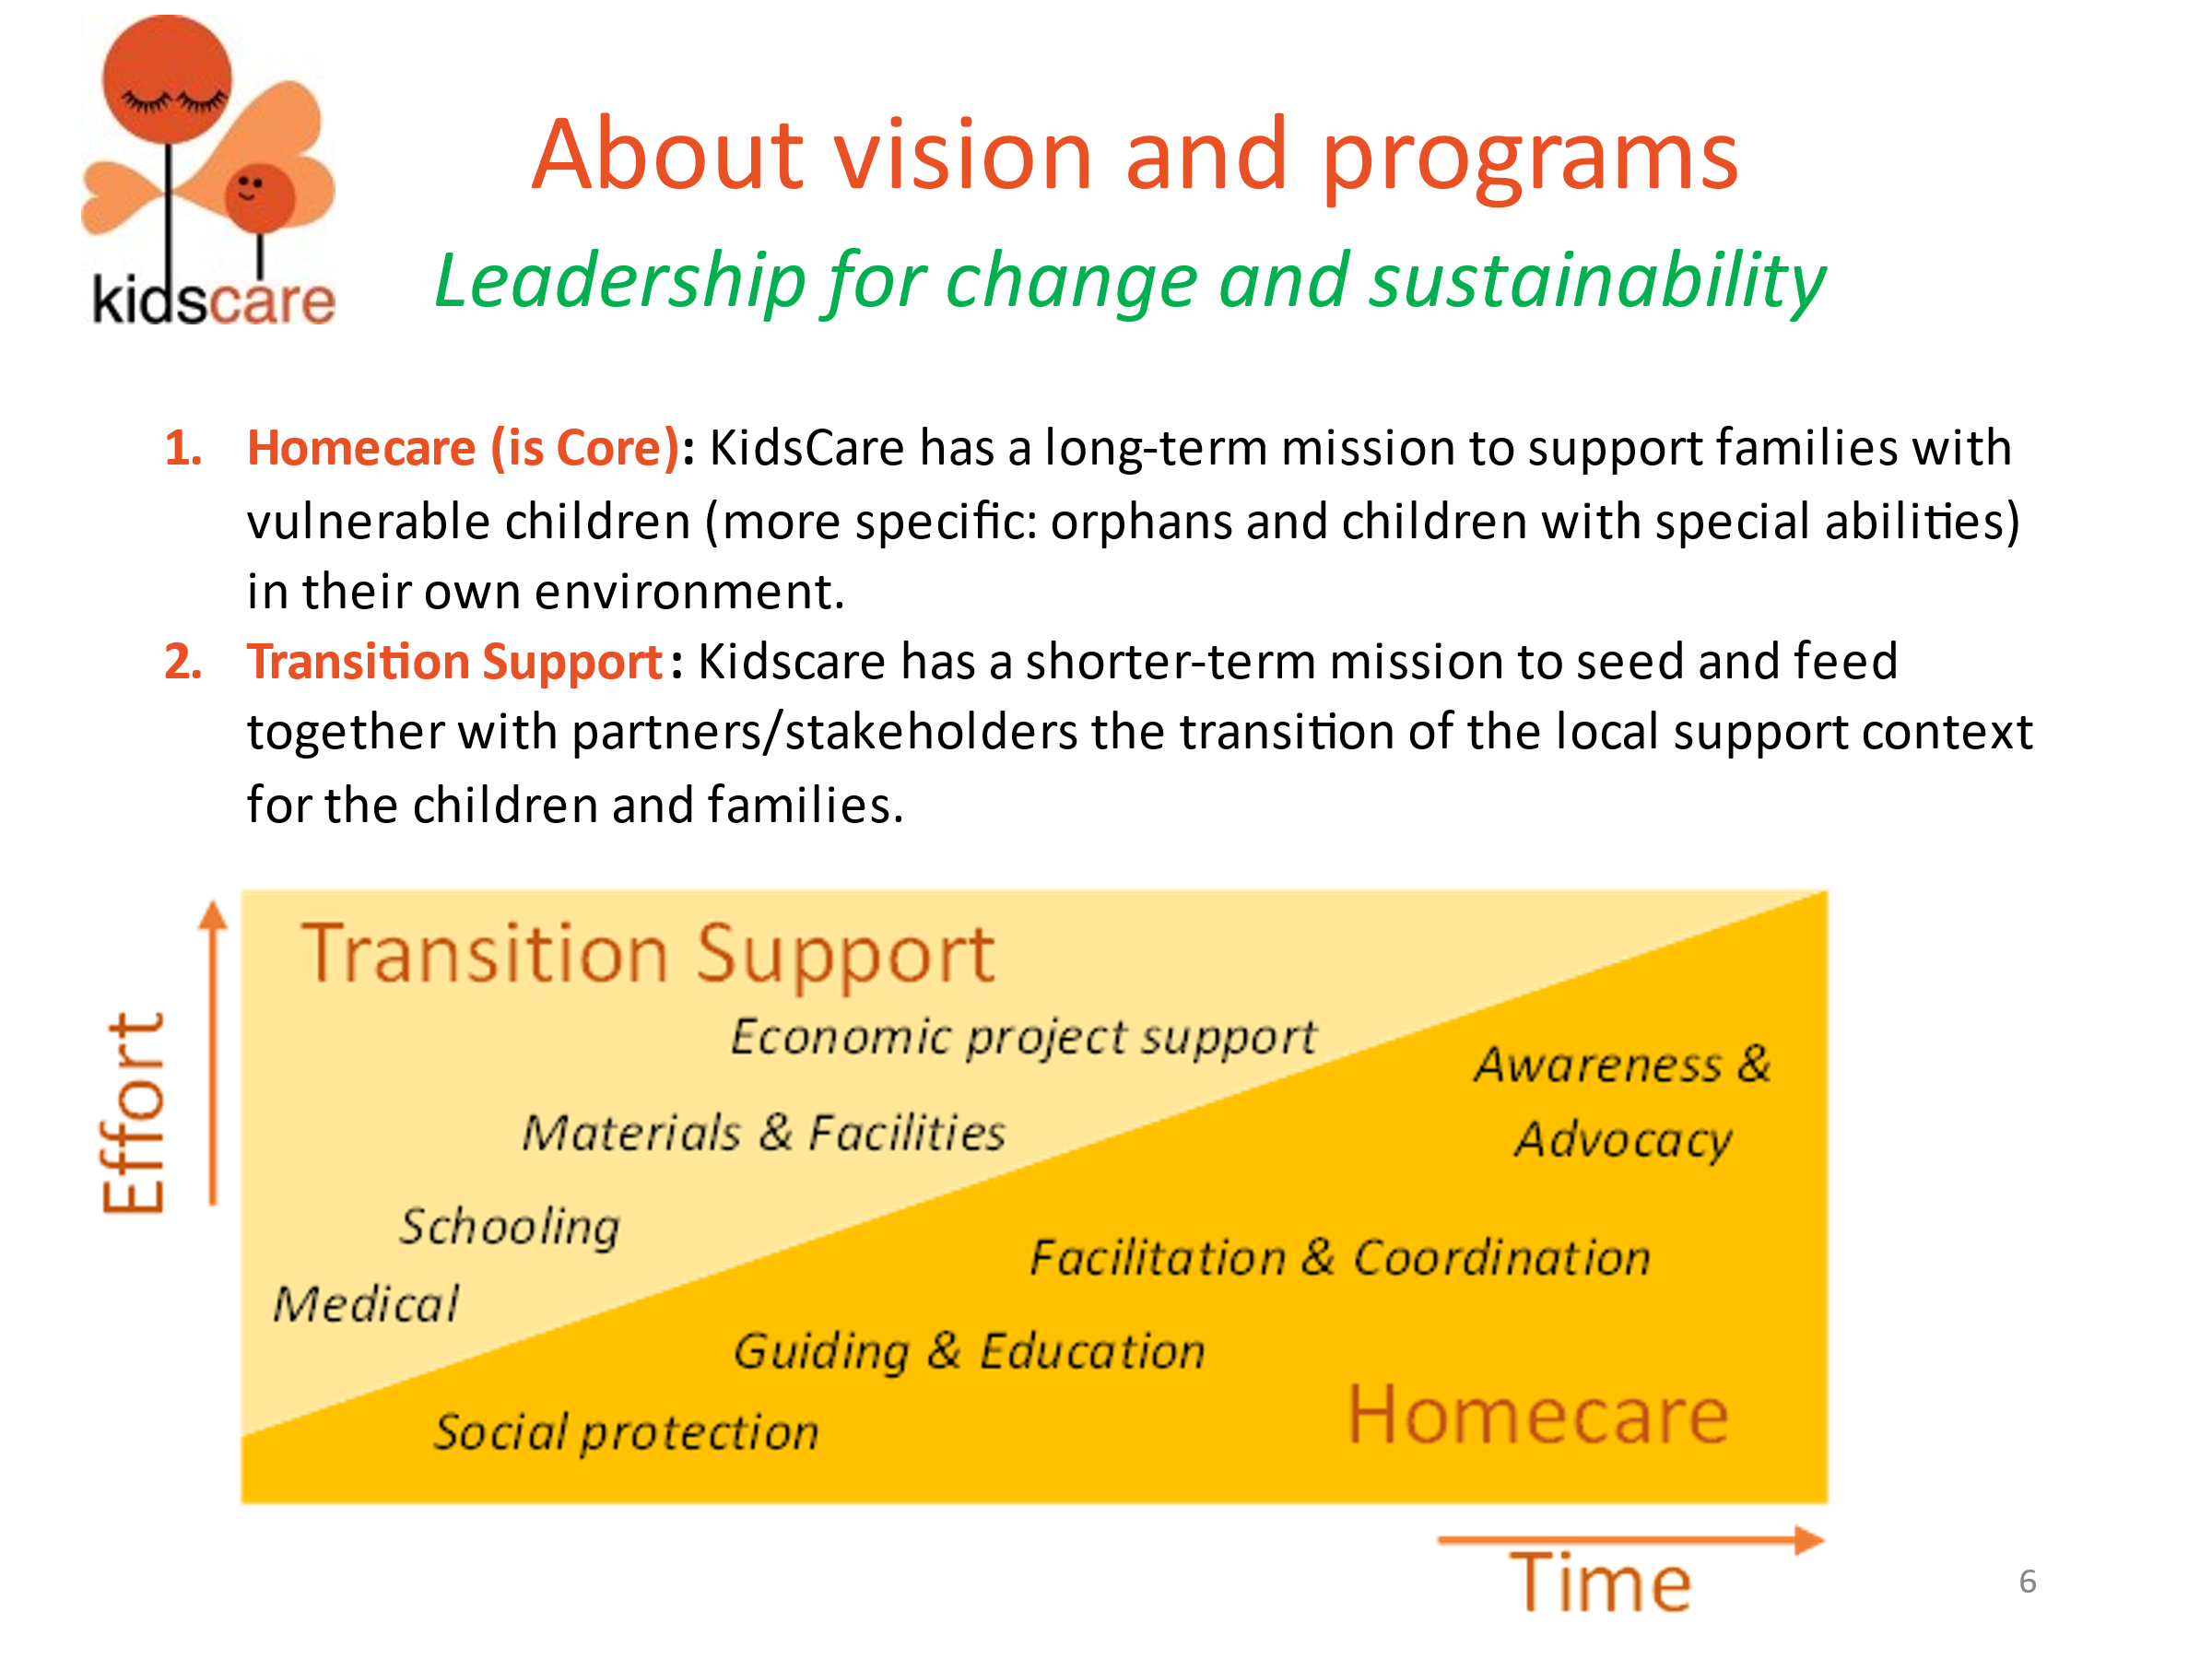
Community Based Homecare program is the core of KidsCare services. To ensure that the families can function independently in the long term and children develop their talents to the maximum, a distinction was developed between 'core services' and 'transition support'. This was particularly placed in time with the assumption that through cooperation with the government, over time it will be possible to leave the 'non-core services' to the government as much as possible.

To clarify the distinction between Core services and Transition Support, the following is further elaborated:

Core services:
- Community Based Homecare
In particular, the social family care in the community:
- For the poorest families (basically with orphans) in selected Communities.
- For children with mental disability and their families.
- For children with physical disability and their families.
- Home visits with tailor-made direct guidance within the family situation also for the most essential economic, educational and health developments.
- Guidance and training of KidsCare Community Volunteers (KCV's and CHV's).
- Referrals to specialized organizations.

- Social (Child) Protection
- Activities at community level (see the CCPC program in 24 communities).

- Awareness and Advocacy
- For caretakers of children with disabilities.

Homecare is always done in close coordination and cooperation with the communities and other local organizations.

Transition Support:
- At the moment necessary Transition Support services for the different target groups of children are:
- Money Transfer (max. K.Sh 1.500 per month).
- Community farmer group activities (farmers' cooperatives including an extensive bee keeping project).
- Support group activities for caretakers of children with disabilities (goat project).
- Weekly therapy sessions for 100 children with physical disabilities.
- Special education in 6 Special School Units for up to 125 children (SSU program).
- Scholarship (being phased out because the government is now doing more for that).

- Intervention programs:
KidsCare wants to help families structurally by working together with them on a sustainable independent existence. For this reason, emergency aid is not seen as a basic part of its programs. However, it has turned out that providing emergency aid is sometimes a prerequisite for being able to work with families on sustainable solutions. Based on current developments, it must be taken into account that emergency aid will be called upon regularly. An amount is therefore reserved annually for this aid.

Emergency aid in the form of food and seed projects has already been successfully deployed by KidsCare. KidsCare wants to cooperate more on this with the government and other organizations such as the Kenya Red Cross for effectiveness and efficiency.
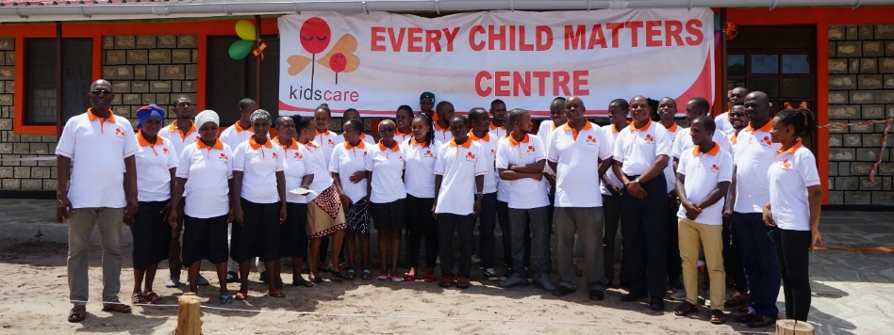

Desired results programs
- To maintain sustainability of homecare programs through annual working with about 2500 children to create a better future.
- All homecare programs to maintain the connection with the communities from beginning till the end with credibility.
- To increase the capacity in quantity and quality by cooperating with external specialists from the government or other relevant organizations.
- To ensure that sharing of responsibilities and tasks with the government and other relevant stakeholders is done in a more tangible way.
- To ensure the homecare programs have sustainable social and economic impact by ending the homecare program with a positive hand-over to other supporting parties/ stakeholders.
- To increase the program outputs especially the outcomes, through advocacy (mobilizing) of the program stakeholders.
- To ensure appropriate feedback on yearly basis through satisfactory surveys among (representatives of) the direct beneficiaries and volunteers.
- To ensure accountability through quarterly reports from the project managers.
On our program services, we are continuing with our current programs but in 2023 we have to actualize/ restart also some of our program services. In the action plan 2023, you find more about the following programs:
- Community Based Homecare Child Protection and Beekeeping (CBHCPB) program (First phase started June 2020 for 3 years)
- Community Based Homecare and Beekeeping (CBHB) program (Start in July 2023)
- Community Child Protection Committees (CCPC) program (Actual restart in January 2023 for in total 3 years)
- Special School Units- 2 (SSU-2) program (2 years’ program start January 2023. Is successor of SSU-1)
- Special Services for Children with Physical Abilities (SS-P) program. (start in revised form in January 2023)
- Community Based Homecare for Children with Mental Abilities (CBH-M) program (start in revised form in September 2023)
- Intervention projects 2023 (to develop and start together with partners and depending of the needs/available budgets)

More about the programs is to be found in the appendix B.

7. Monitoring & Evaluation
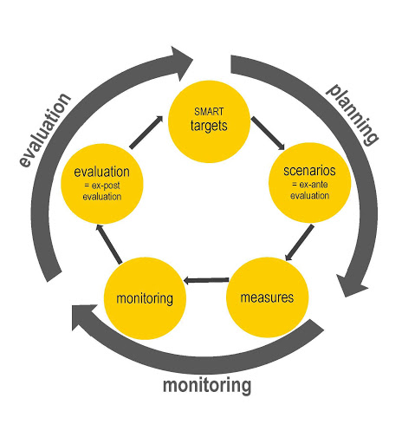
Monitoring is a systematic and long-term process that gathers information in regards to the progress made by an implemented program or project. Evaluation is time specific and is performed to judge whether a program or project has reached its goals and delivered what was expected according to its original plan. It enables tracking down bottlenecks in our operations and provides management information to act upon. Lastly, monitoring and evaluation provides transparent information for (potential) donors.

Main goal
To ensure the most effective and efficient desired results of the programs and tracking the key elements of the programs to have Insights into and continuous improvement of programs and projects.

Situation KidsCare
Current running year planning monitors:
- Departmental quarterly goals (Management Team, homecare CBHCPB , CBHB,CCPC, homecare CSA, SSP, SSU-2, sustainability, finance, HR, farm, facility)
- CBHCPB households
- CBHCPB groups
- Outreaches
- Special Services physical (testing)
- HR cycle

Listed to be developed:
- Sustainable impact overview

Desired results (general)
- To have every year a clear (smart) action plan in line with this strategic plan.
- To have an effective data base system by developing appropriate standard tools.
- To ensure timely update and reporting of relevant information/data.
- To ensure proper monitoring and evaluation of all the programs using standardized tools and reporting.
- To ensure organisation resources are efficiently utilized through frequent quality checks.
- To ensure transparency and accountability from project start, its implementation and project exit to the donor and also the organisation.

Find our action plan for 2023 in the appendix C.

8. Finance
Below work model is given of KidsCare estimates/ budgets for the years 2023 -2025. In this schedule we only mention the ‘normal exploitation’. The income / expenditure for ‘external investment costs’ is not noted in this schedule because they interfere with the insight in the cost of the running programs and organization.
Although sometimes the difference is not completely clear, we define ‘normal exploitation’ as the cost of running the current homecare programs and all internal organization. The expenditure of big investments (like new buildings and inventories) are not in the ‘normal exploitation’. For the coming year we don’t expect big investments and if is to be done we have to find separate ways to finance such investments. Below is an overview of the exploitation in K.sh and in Euro’s:
In K.Sh.

In Euros ( rate Euro/ K.sh is 1/120)

The budgets during the years 2024 -2025 are temporary budgets. Due to many circumstances like, with the current high inflation, we are not sure what will come in these years. For now, this is the best we could do. The assumptions for the exploitation in the coming years are:
- We expect an average yearly inflation of 10%.
- We don’t expect autonomous growth in the coming 3 years.
- The income from donation realized by the Kenyan team will rise from about 30% to 70%.
- Our programs will go on in the line as this year and as planned in this plan
- Income and cost will be every year in balance.
- Through calculation, our yearly depreciation cost of the assets we bring in these costs. If possible, we build some reserves through that.

Special attention will be given to make our financial administration and their way of working more efficient. Having a higher IT standard will be part of that ambition.

Also, the financial system for budgeting and monitoring on organisation and program level will improve. We did make steps forward but, still that needs more attention from the financial department and also from all team members.

We continue with our quarterly financial reporting to the board and to our main donors. Being transparent must be one of our strengths.

Appendix:

A. Organisation Chart

B. Our programs 2023 -2025

C. Year plan 2023

